Woodwork Bench Continued by Keith Davidson

Routing the groove for the well board:

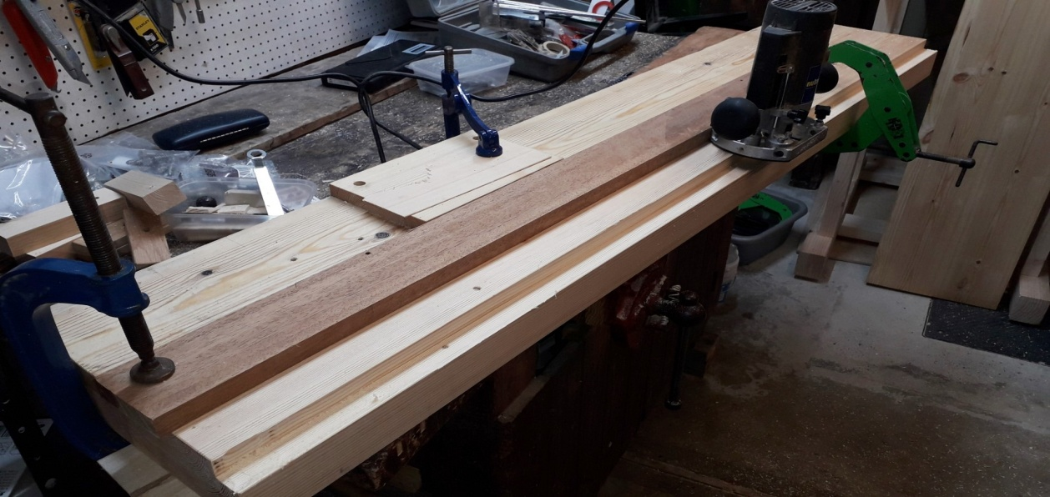

A Forsterner bit went AWOL when drilling the recesses for the heads of the vice holding coach bolts. This needed a patch to be spliced in, unfortunately.

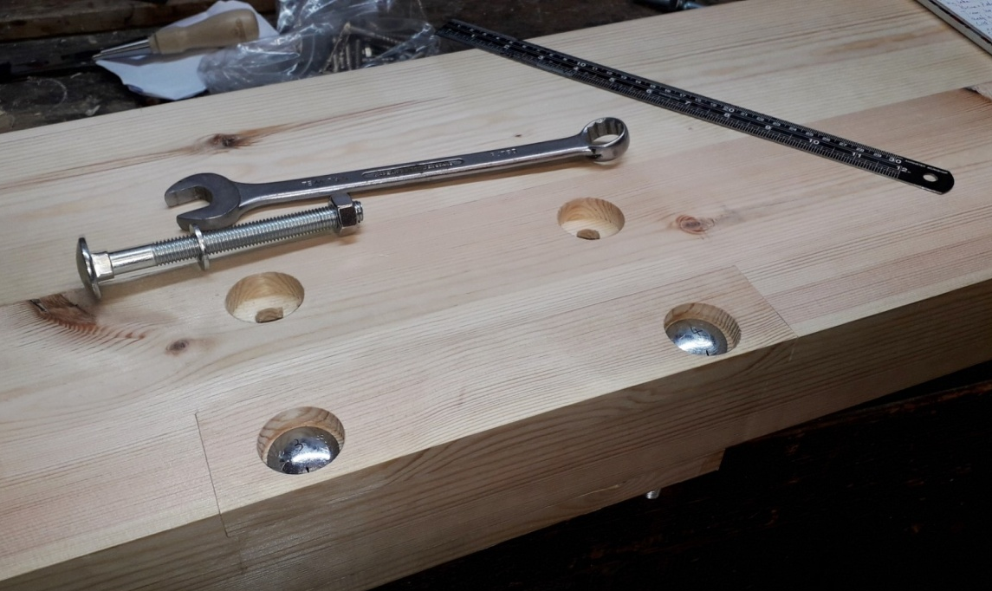

The finished patch, which I can live with. With four M12 bolts through 3” of timber, the vice is not going anywhere.

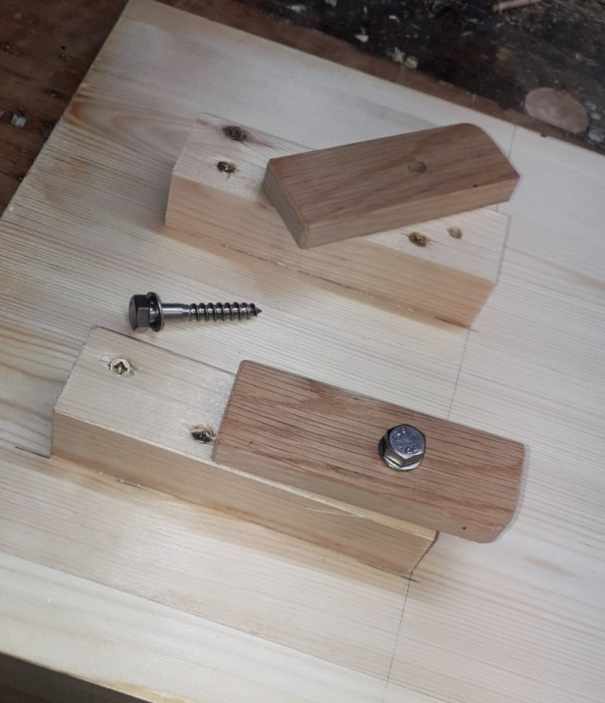

Huge buttons to hold the well board down. The calculated worst case change in width due to local temperature and humidity variations is 12mm across the width of the top. Half of the thick worktop already needs re-flattening, as over the last few weeks it has warped to be convex.

The finished framework: The diagonal pairs in each of three axes are (almost) equal. You can just see the top of the further trestle above the nearer, with no discernable wind. So all square and rock steady- absolutely no need for a diagonal brace. Champion!

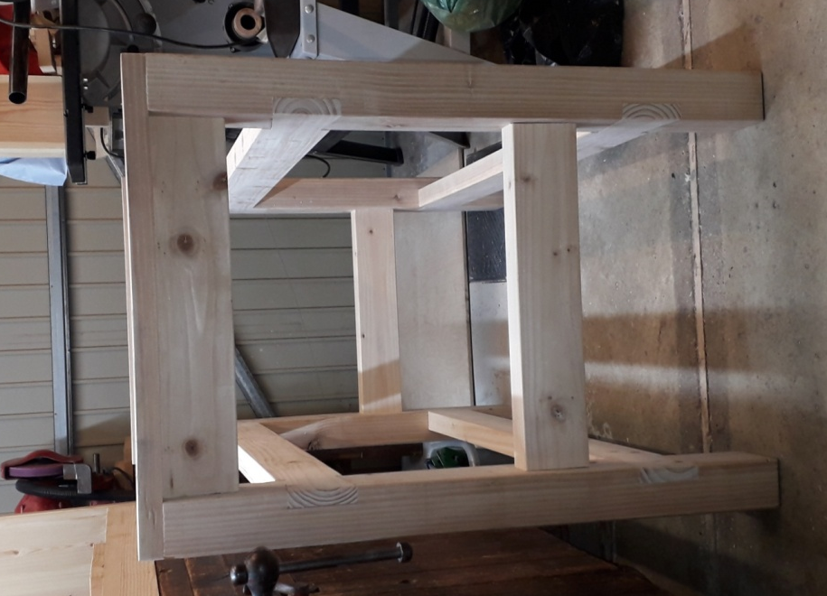

When I ordered the shed, chatting to one of the staff about timber and workbenches etc. he commented “You can’t over engineer a work bench.” Having made fitted wardrobes years ago, this is not the largest project I have tackled, but it is definitely the heaviest. With the help of the bathroom scales measuring the individual components, I estimate the weight of the complete bench to be over 66kg (10stone 5lbs. in old money), so it may be just a tad over-engineered!
All the pieces fit together but the bench will remain in bits for easier transportation to its new home, when it arrives. (ETA 15/7/21, if you believe them!)

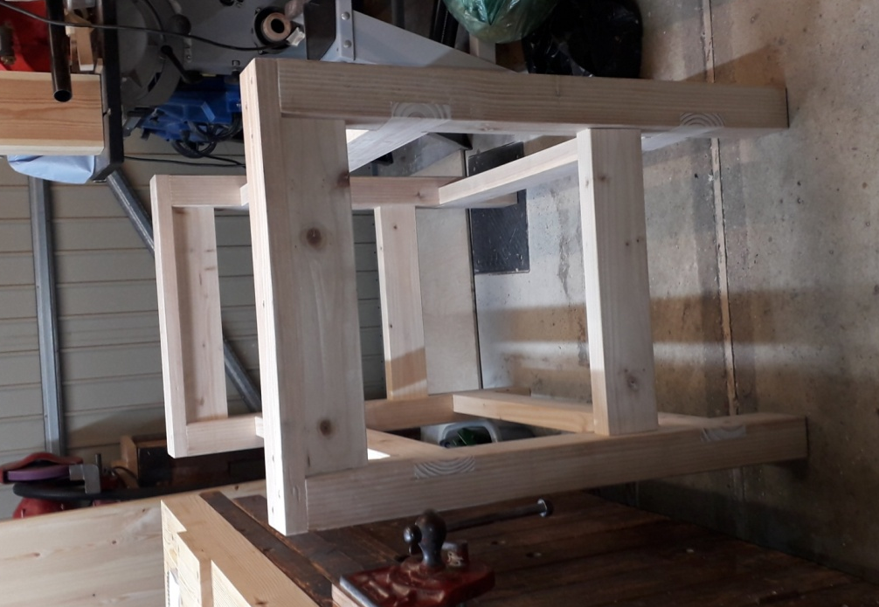

The next project will be something a bit more relevant to NWA; a dedicated bench for my lathe.

